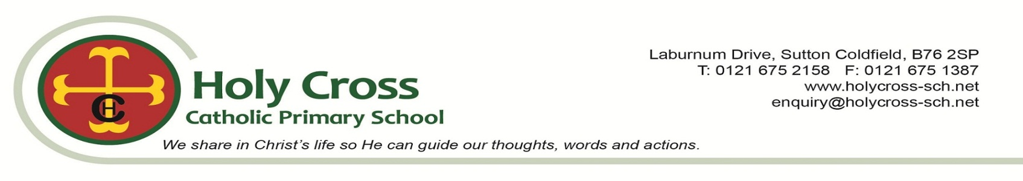
SUPPLEMENTARY INFORMATION FORM SEPTEMBER 2026 INTAKE
PLEASE RETURN TO THE SCHOOL OFFICE BY 15 JANUARY 2026 at 11.59pm
Please note that parents/person with parental responsibility are also required to complete the Local Authority Preference Form. This form is not an application for a place at Holy Cross School.

Child's Details
Surname
Forenames
Date of Birth
Address

Post Code

Telephone Number

Email Address
Within the parish boundary of

If the child has a brother or sister currently attending Holy Cross School, please give details below.
Surname |  | Forenames
Surname |  | Forenames
Surname |  | Forenames

Baptism Details - If the child has been baptised in the Catholic faith please give details below and provide a copy of the baptismal certificate with this form.
Name of Church
Address
Date of Baptism
Continued overleaf

I have read the Holy Cross School Admission Policy and I understand that the information on the SUPPLEMENTARY INFORMATION FORM will be used by the school and the parish. I understand that if I have given incorrect information it could invalidate the offer of a place at Holy Cross School.

Signed: ................................................................................Print Name: .....................................................................................

Date: .......................................Parent/Person with parental responsibility of: ...........................................................

Please ensure that you have included:

- Official verification of permanent address (Council Tax Bill)

- Copy of Baptismal certificate

All supplementary information forms should be returned to Holy Cross Catholic Primary School, Laburnum Drive, Sutton Coldfield. B76 2SP. Or emailed to: enquiry@holycross-sch.net

PLEASE ENSURE THAT YOU HAVE COMPLETED ALL PARTS OF THIS FORM.

PLEASE RETURN TO THE SCHOOL OFFICE BY 15 JANUARY 2026

